# **JAABA Instructions on Compute Canada**

### Process data by JAABA

1. Make sure to upload choreography input and result under  
   '/project/6010970/screen/choreography_input /' AND   
   '/project/6010970/screen/choreography-results/'
2. Go to the following directory and copy the highlighted file into your scratch folder.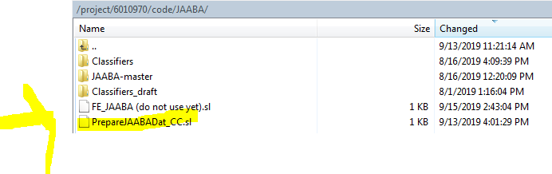
3. Open the file and modify 1 and 2, then save  
   1: genotype info  
   2: classifier name ( located under '/project/6010970/code/JAABA/Classifiers/')  
   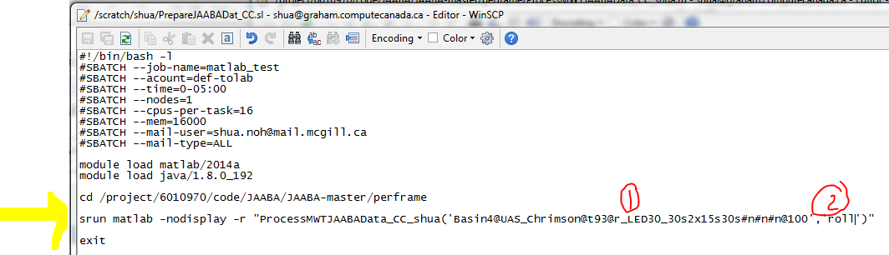  
   **#SBATCH –time=0-05:00 means 5 hours. You can extend or shorten according to the number of timestamps (1 timestamp==5-6 minutes)
4. Click the double monitor button OR open putty  
   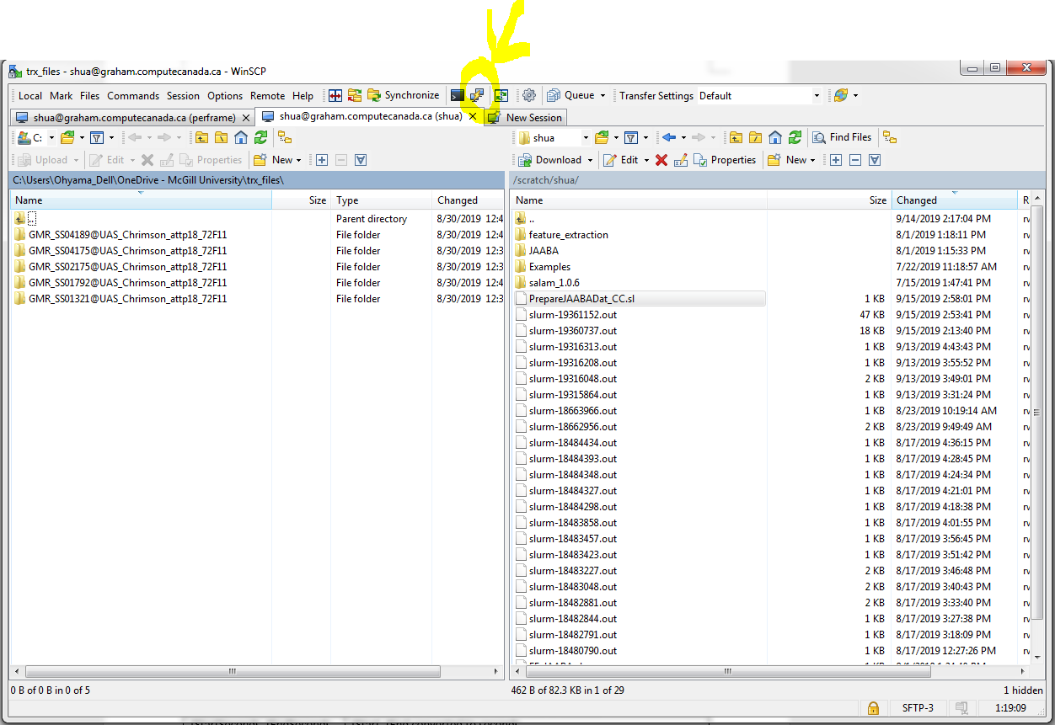
5. In Putty,
   1. Log in, then write the following commands:
   2. cd scratch
   3. sbatch PrepareJAABADat_CC.sl
   4. Once it starts running after waiting, you will receive an email
6. Outputs are stored under ‘/project/6010970/screen/JAABA_processed/’  
   **scores_((classifier name))_update.mat**:

|  |  |
| --- | --- |
| scores | If value<0, NOT a behavior  If value>0, IS a behavior |
| tStart, tEnd | Frames where tracking starts, ends |
| postprocessed | If value=0, NOT a behavior  If value=1, IS a behavior |
| t0s,t1s | Frames where behavior starts, ends |
| timestamps | Seconds at each timeframe |
| t0sProcessed, t1sProcessed | Currently,   1. <=4 frames gaps are combined 2. <=3 frames duration behavior are erased   You can change the threshold in ‘…\Documents\JAABA\JAABA-master\JAABA-master\perframe\PostProcessJAABA_shua.m’ |
| T0sSeconds, t1sSeconds | t0sProcessed, t1sProcessed converted to seconds |
| tStartSeconds, tEndSeconds | tStart, tEnd converted to seconds |

-------------------------------------------------------------------NOT AVAILABLE YET---------------------------------------------

### Turning JAABA data into ‘((genotype)).crabspeed_area-animal_stats_rolls_JAABA.txt’ (same as files created after running feature extraction)

1. Load Matlab 2019a.
2. Double click script_JAABA_makeanimalstat as followed.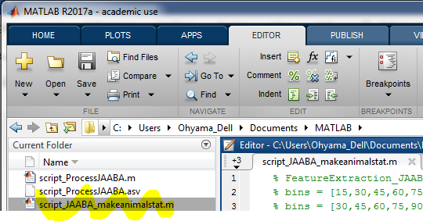
3. Write the commands (fill in genotype and time bins), drag, right-click, and select **Evaluate Selection**.  
   *If multiple genotypes, drag multiple command lines
4. Output will be created under ‘…\Documents\feature_extraction’  
   *Takes a short time  
   \***((genotype)).crabspeed_area-animal_stats_rolls_JAABA.txt** is created inside each timestamp and outside timestamps (all combined)